esimese asjana ma laadisin sqlite-i arvutisse ja kui see oli ära laadinud hakkasin seda kasutama.

**ül1**

c:

cd c:\sqlite

sqlite3 epood_dmahdi.db

SELECT * FROM tabel;

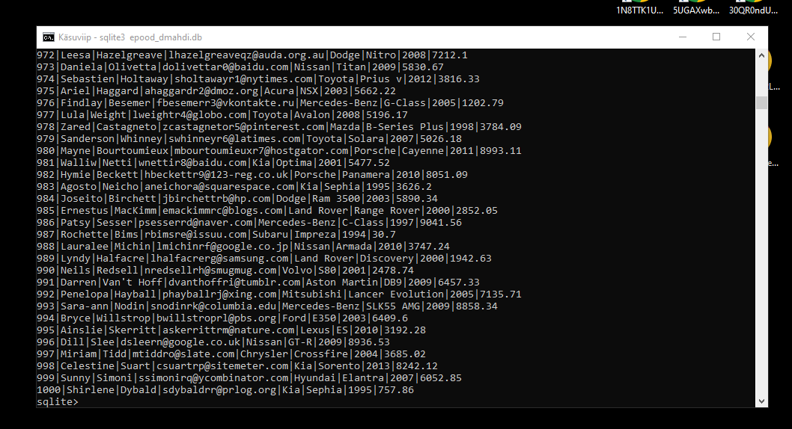

**ül2**

UPDATE tabel SET car_make='Zaporožets' WHERE id=16;

UPDATE tabel SET car_make='Citroën' WHERE car_make='Cadillac';

DELETE FROM tabel WHERE id IN (5, 10, 15);

SELECT id, last_name, car_make, car_year FROM tabel ORDER BY id ASC;

SELECT id, last_name, car_make, car_year FROM tabel WHERE last_name LIKE 'A%' ORDER BY car_year DESC LIMIT 10;

SELECT * FROM tabel WHERE car_make IN ('Toyota', 'Mercedes') AND summa > 5000;

**ül3 ja 4 githubis**

https://github.com/dajanaIT-21/PHP